**Relational model:**

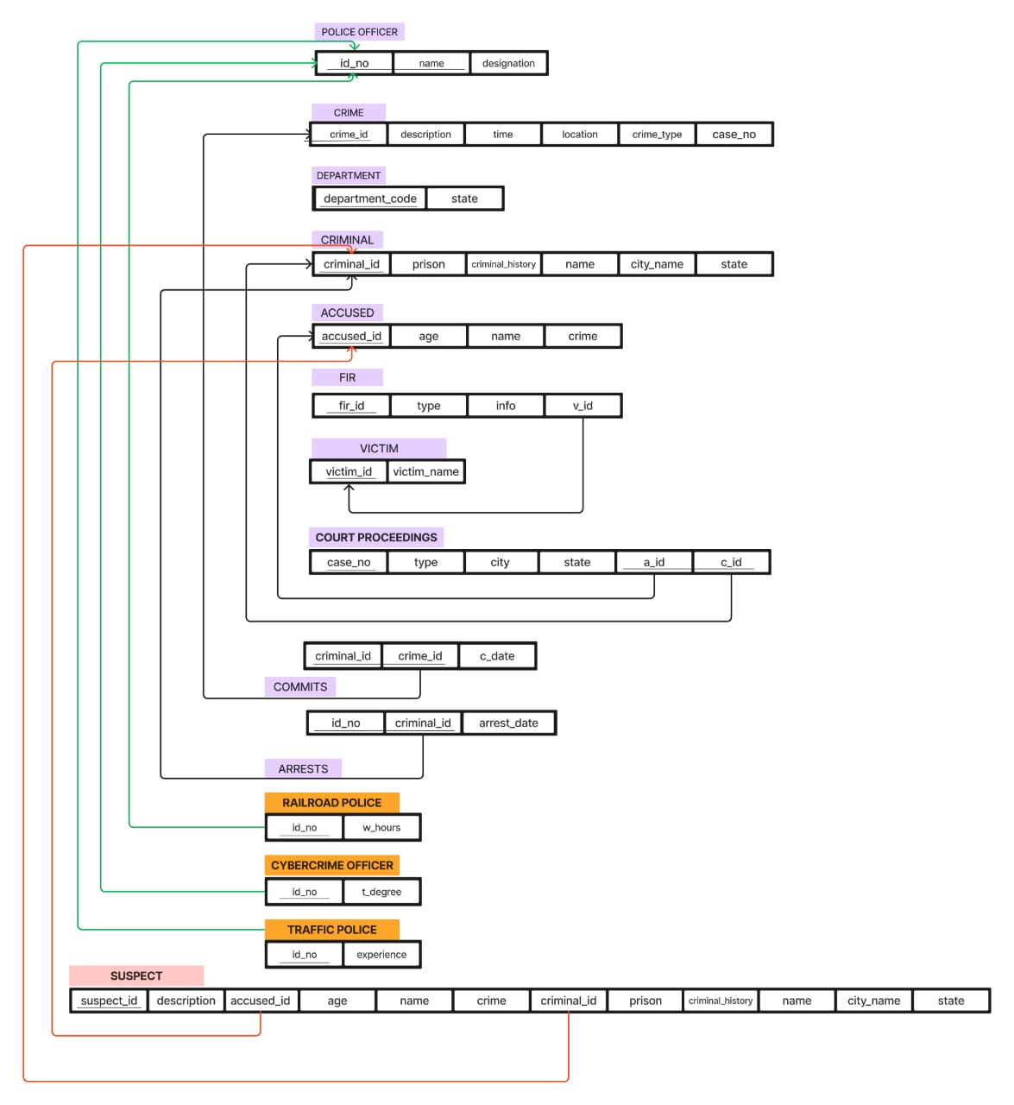

Conclusion: LO1 mapped